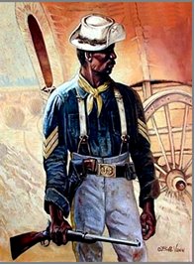
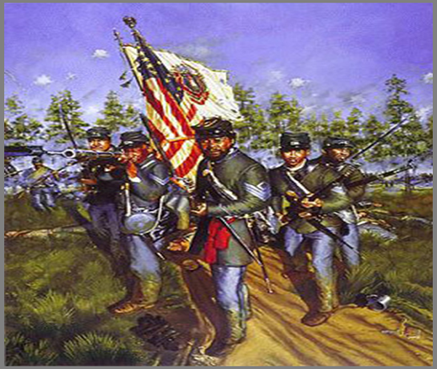

Buffalo Soldiers Motorcycle Club, Albuquerque Chapter
Scholarship Application

General Information / Instructions

The Buffalo Soldiers Motorcycle Club, Albuquerque Chapter, is pleased to announce we are accepting applications for our $1000.00 scholarship award for the 2022-2023 academic year. We are soliciting Albuquerque and surrounding public HS graduating seniors to compete for a scholarship that will be awarded May 2023. The scholarship criteria are as follows:

. New Mexico High School Graduating Senior

. Academic performance and eligible to graduate (minimum 2.5 average GPA. Copy of transcript and school counselor initials from current institution are required.)

. Essay of 750 words but no more than 900 words that answers the following TWO questions:

a. How does the legacy of the Buffalo Soldiers inspire you to solve a problem currently facing
our society?

b. How will the Buffalo Soldier Motorcycle Club, Albuquerque Chapter Scholarship help you?

. Two letters of recommendation (written by someone other than a relative)

Completed applications must be post marked no later than April 17, 2023. If you have questions or require additional information, please contact Rene Matison via email: rpmatison@msn.com

Personal Data:

- Name: ___________________________ ____________________________ ___________________
(Last) (First) (Middle)

Email: _____________________________ High School ______________________________

Address ___________________________________________________________________

City and State ___________________________________________________Zip Code ____________

Phone Number (____) ______________________

2. Father's Name _____________________________________Occupation ________________________
(Guardian)

Address ___________________________________________________________________

City and State __________________________________________________Zip Code _____________

Phone Number ( ____ ) ______________________

3. Mother's Name ____________________________________Occupation _________________________
(Guardian)

Address ____________________________________________________________________

City and State ___________________ Zip Code _________

Phone Number ( ____ ) ______________________

4. How did you learn about the BSMC Albuquerque Chapter Scholarship Program?

________________________________________________________________________________________

IMPORTANT: Information requested for the following items must be provided in the space below or on a separate sheet. If not using this application form, the information provided must be in the same sequence with the same headings as requested on this official form. Information provided on a separate sheet will NOT be considered if it is not in the format and sequence as herein outlined.

5. Participation in student organizations/activities in conjunction with coursework: (i.e., Student Union, Science Club, DECA, etc.)
___________________________________________________________________________________
___________________________________________________________________________________

6. Leadership Role(s): (i.e., Club President, Secretary, Treasurer, Committee Chair, etc.)
___________________________________________________________________________________
___________________________________________________________________________________

7. Extracurricular clubs/activities: (i.e., Band, Best Buddies, Key Club, etc.)
___________________________________________________________________________________
___________________________________________________________________________________

8. Participation in organizations and/or community service outside of school: (i.e., Mentoring, Feeding homeless, Big Brothers/Sisters, etc.)
__________________________________________________________________________________
__________________________________________________________________________________

9. Honors/Awards/Scholarships awarded: (i.e., Kodak Award, National Young Leaders Conference, National Honor Society, Dean's List, Who's Who, etc.)
__________________________________________________________________________________
_________________________________________________________________________________

Academic Data:

10. Present grade point average: (Based on 4.0): __________________________

11. To be completed by school counselor: Eligible to graduate? ________ Yes ________ No

School Counselor Initials: ________

12. Name of college/university or other educational institution to be enrolled in upon graduation:

_________________________________________

13. Intended Major Field of study: __________________________________________________________

Certification:

The information on this form is true and complete to the best of my knowledge. The essay is my original work. I hereby give the BSMC Albuquerque Chapter permission to use my name and photograph for the purpose of public relations.

______________________________________________ __________________
Student's Signature Date

________________________________________________ ___________________
Parent/Guardian Signature (if applicant is a minor) Date

Mail Application, Transcript, Letters of Recommendation, and Essay to:
Buffalo Soldiers Motorcycle Club, Albuquerque Chapter
c/o Rene Matison –Scholarship Chair
PO B0X 57061
Albuquerque, NM 87187

